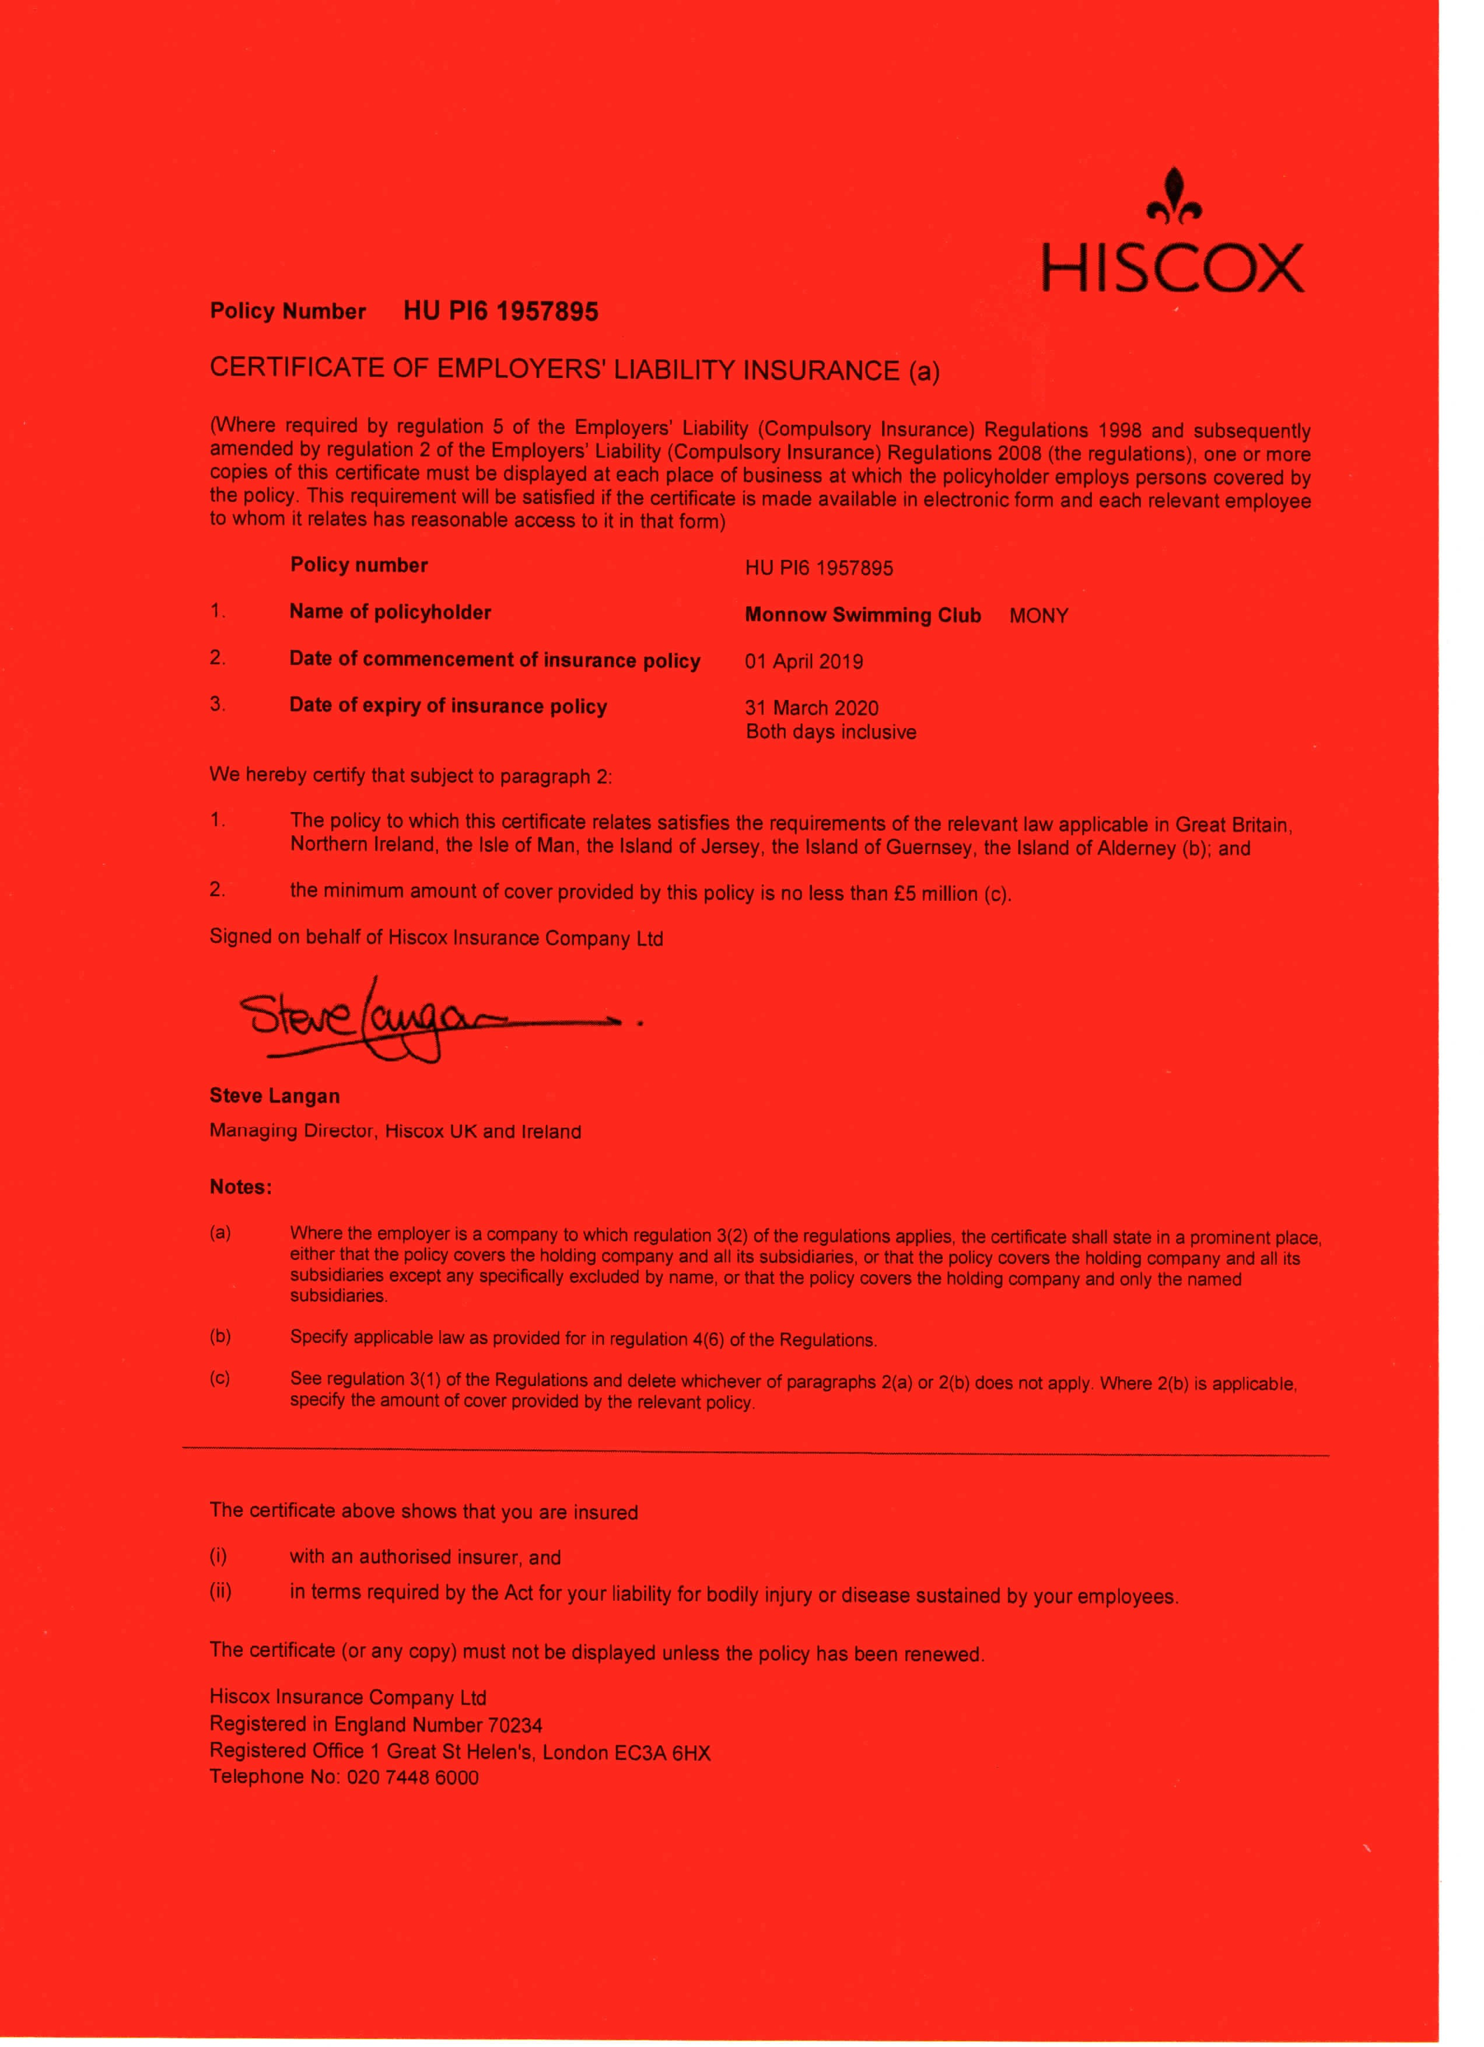

NOFIO CYMRU
SWIM WALES
Swim Wales Nofio Cymru

Mr R Nock
Monnow Swimming Club - MONY Beaulieu Ridge Farm
Staunton Coleford GL16 8PB

April 5, 2019

Dear Robert

Please find enclosed your 2019/20 Swim Wales club insurance certificate.

These certificates should be kept in a safe place and copies of the Employers Liability Certificate should be displayed at all venues that your club trains at.

If clubs have a wage roll which totals in excess of £50,000.00 they will need to inform our insurers Howdens on 0121 698 8050.

Claims Notification Requirements

It is important that all incidents that may give rise to a claim are reported to our insurers Howdens as soon as possible after the event. This will enable Insurers to carry out investigations at an early stage whilst information relating to the claim remains fresh in the mind. This will also ensure that you are complying fully with your policy terms and conditions.

Additionally you are also required to comply with the amendments to the Ministry of Justice procedures which came into effect on 31st July 2013. These require disclosure of insurance details within 24 hours of contact by Third Party solicitors following an injury where you may be liable. Failure to comply with the revised procedures will result in a sharp increase in costs.

In order to achieve this, we ask that you notify Howdens immediately of any incident that involves:-
- a fatal accident.
- an injury involving either referral to or actual hospital treatment.
- any allegations of libel/slander.
- any allegations of Professional Negligence i.e. arising out of tuition, coaching or advice given.
- any investigation under any child protection legislation .
- any circumstance involving damage to third party property.

If you have any queries with regard to your insurance do not hesitate to contact us. Regards

Swim Wales Membership Services 01509 640727
swimwalesrenewals@swimming.org

'
Swim Wales.
Membership Services SportPark, Pavilion 3
3 Oakwood Drive, Loughborough University, LE11 3QF Tel: 01509 640727 Email: swimwalesrenewals@swimming.org

N O F IO CYMRU SWIM WAL E S

SWIM WALES
Summary of Insurance Cover 2019-20

ALL AFFILIATED SWIMMING CLUBS

Name of Club: Monnow Swimming Club Affiliation Number: MONY

By virt ue of affiliation to Swim Wales, the above named Club is entitled to the following insurances whilst participating in any activity recognised and/or authorised by Swim Wales (and approved by the insurers).

Cover is provided to UK residents only.

Period of Cover: 01 April 2019 to the 31 March 2020

COMBINED LIAB ILITY

Policy Numbers: Primary Insurer: Excess of Loss Insurer:

Retroactive Date:
Primary - HU Pl6 1957895 & Excess of Loss - EC798249 Hiscox Insurance Company Ltd
Zurich Insurance Company Pie (Excess of Loss not applicable to Employers Liability) 01 January 1985 (or date of last continuous membership whichever is lat er)

Entitled to Indemnity: The affiliated Clu b, including its directors, officers, employees, coaches, teachers , members and voluntary helpers whilst representing the club

Important The Liability Insurances below (with the exception of Employers Liability) is provided on a " claims made" basis . It is essential that any claims or circumstances that might give rise to a claim are notified during the policy period in accordance with the terms of the policy wording otherwise the right for indemnity under this insurance will be
fo rfeit ed.

PUBLIC LIABILITY /PROFESSIONAL INDEMNITY
This covers legal liability for damages and legal costs arising out of Third Party loss, injury or damage, in connect ion with the activities described above and notified to the Insurer within the period noted above. Cover includes public liabilit y, professi onal indemnity, financial loss, libel and slander, abuse, liability for damage to leased and rented premises, member to member liability, indemnity to principals and liability arising out of goods sold or supplied includ ing refreshments.

EMPLOYERS LIABILITY
This covers legal liability for damages & legal costs arising from the death or bodily injury to employees (voluntary or paid) in the course of their employment with the club, region or county. This cover is written on a claims occurred basis . Which means the policy will respond to an incident that occurs during the period of cover.

A separate Certificate needs to be displayed in the work place by law if you have employees . Swim Wales will issue an Employers Liability Certificate to you.

MANAGEMENT LIABILITIES - DIRECTORS & OFFICERS (D&O) & CORPORATE LEGAL LIABILITY
These sections provide cover for the personal liability of Directors & Officers in their capacity as Insured Persons of the Policyholder and for the Club entity for actual or alleged error, misstatement, omission, neglect or breach of duty, or other act actually or allegedly committed or attempted in respect of all claims made against the Policyholder and notified to the Insurer during any Period of Insurance.

Howden is a trading name of Howden UK Group Limited, part of the Hyperion Insurance Group. Howden UK Group Limited 1s authorised and regulated by lhe Financial Conduct Authority in respect of general insurance business Registered in England and Wales under company registration number 725875
Registered Office. One Creechurch, London EC3M 1BD Calls may be monitored and recorded for quality assurance purposes.
03.2019 SW Members SOC

LIMITS OF INDEMNITY

Public Liability | £20 million | any one claim
Products Liability | £20 million | any one period (costs inclusive)
Abuse Extension | £20 million | any one period (costs inclusive)
Professional Indemnity | £20 million | any one claim

Management Liability Directors & Officers (D&O) Management Liability Corporate Legal Liability
Employers Liability
£20 million

£20 million

£10 million
any one period (costs inclusive) any one period (costs inclusive)
any one claim (Terrorism £5 million any one period)

Inner Limits apply eg. Pollution £100,000 under Public Liability & Corporate Legal Liability - please refer to the policy wording for full details.

Restricted cover applies in respect of legal actions brought in a court of Law within the USA or Canada

Principal Exclusions

Liability arising out of:

- Criminal Acts •
- The ownership, possession or use of any mechanically • propelled vehicle, aircraft, hovercraft or water-borne craft •
- Product Guarantee or recall, repair or replacement •
In connection with damage to any data
- Medical malpractice
Damage to own property
Abuse in respect of the individual accused or alleged to have committed abuse or have permitted abuse Incidents prior to the retroactive date
Incidents/ claims known to you but not reported to Insurers.

Excess: £2,500 each & every claim in respect of Corporate Legal Liability

PERSONAL ACCIDENT

Policy Number: Insurer:
Insured Persons:

PA00021224
Royal & Sun Alliance Insurance pie
All bona fide members of the club resident in Britain

Cover

Injury arising out of swimming and aquatic sports including dry-side training recognised and or authorised by Swim Wales in which the Insured Person is participating

BENEFIT DESCRIPTION BENEFIT Scale of Benefits AMOUNT

Death £5,000 Permanent Partial Disablement

- Loss of two or more limbs or eyes or
 | one of each
3 | Loss of one limb or one eye | £30,000
 | Permanent & total loss of speech | £30,000
 | Permanent & total loss of hearing
 | i) In both ears | £30,000
 | ii) In one ear | £7,500

£30,000

The percentage shown below shall be applied to the Limit per Person under Benefit 3

Loss by permanent physical severance or permanent and total loss of use of
  - one big toe 15%
  - any other toe 6%
  - one thumb 30% '
  - one forefinger 20%
  - any other finger 10%

4 Permanent Total Disablement from gainful employment for which the Insured is fitted by way of training education or experience
s Temporary Total Disablement from the Insured Person's Regular Gainful Employment

(payable for a maximum 104 weeks with a 14 day excess)

£30,000

£75 per week
Permanent total loss of use of
- shoulder or elbow 25%
- wrist hip knee or ankle 22%
- a foot below the level of the ankle
(talo-tibial joint) 50%
- the back or spine below the neck
with no damage to the spinal cord 40%
- the neck or cervical spine with no damage to the spinal cord 30%

Removal by surgical operation of
- lower jaw 30%

For forms of permanent disablement not specified the degree of disability will be assessed by comparison with the percentages shown in the scale without taking into account the Insured Person's occupation The appropriate percentage shall be applied to the amount for Benefit 3 shown in the Schedule or to the Limit per Person under Benefit 3 whichever is the lesser

Benefit 5 is not payable to persons under the age of 16 years.

In respect of members aged 70 to 85 years of age benefits 1, 2 and 3 only apply.

Cover applies until the expiry of the Period of Insurance in which the Insured Person attains the age of 85 years.

Special Extensions

Accidental Medical Expenses Bereavement Counselling Coma Benefit

Convalescence Counselling Dental Expenses

Dependents benefit
Up to £2,500 any one Insured Person
Up to £250 per week to a maximum of £5,000
£50 per full 24 hours up to a maximum of 104 weeks any one Insured Person
£200 per Insured Person reduced to £100 if Insured Person is aged 70 years of age and ove_r
Up to £250 per week up to a maximum £5,000 any one Insured Person
Up to £250 any one Insured Person for any one Accident
reduced by 50% for those aged 70 years of age and over. Subject to £50 excess each & every loss
- -
.,. ..
Additional 5% per Child up to a maximum 25% of Benefit 1
subject to a minimum £5,000

Funeral Expenses
Up to a. maxim.u---m-
£5,000 any one Insured Person

...

Hospitalisation
.. .......

Paralysis
- total loss of use of all four limbs bladder and rectum
- total loss of use of two legs bladder and
rectum
£50 per full 24 hours up to a maximum of 104 weeks any one Insured Person

£30,000
£15,000

Maximum Incident Limit is £25 million subject to the following inner limits:
Multi-engined Aircraft £1 million Any other aircraft
War £5 million Terrorism other than by Nuclear Chemical or Bi_oJogical Cause

£250,000
£5 million

03.201 9 SW Members SOC

Principal Exclusions
Bodily Injury arising out of: Bodily Injury as a result of or contributed to by:

Flying (other than as a passenger),
- Committing or attempting to commit suicide
- Driving a motor vehicle while over the legal limit War or terrorism

LEGAL EXPENSES INSURANCE
- Drugs unless taken on proper medical advice and is not for the treatment of drug addiction
- Undertaking the Insured Sport against medical advice
- Illness or disease
- Post -trau mat ic stress disorder or any psychological or psychiatric condition
- Repetitive stress (strain) injury or syndrome or any
other injury which develops over a period of time

Policy Number Insurer Insured
TTS/3720449
DAS Legal Expenses Insurance Company Ltd
The appointed officials on behalf of the affiliated Clubs of the Association

Operative Covers

Employment Disputes and Compensation Awards Legal Defence including Motor Defence
Property Protection Commercial Legal Advice Tax Protection Redundancy Approval
Counselling Tax Advice
DASBusinesslaw Business Legal Services
Business Legal Healthcheck Personal Injury

Cover includes fees and expenses of solicitors, barristers and expert witnesses, together with court costs and opponents costs if they are awarded against a Club in a civil case

Limit of Indemnity

Extension

£250,000 (Employment Disputes Compensation Awards aggregate limit £2,500,000 any one period)

The Policy also includes a 24 hour Legal Advice helpline which provides free confidential advice on any matters affecting the Club.

Main exceptions

  - Fin ?r other penalties, debt recovery, contract disputes or any Club with excess of £50,000 wageroll (unless not1f1ed to and accepted by the insurer}.
  - Incidents not referred to DAS before action. It is important to involve DAS as soon as you are aware a dispute may occur

'

n ?01 Q \Al Momhcrc ("\('

Access to On-Line DAS Business Law

Businesslaw is the legal information and document preparation website for businesses. You will find expert advice and Valuable document building tools to help you run your company and resolve tricky legal issues.

Visit www.dasbusinesslaw.co.uk.

There is no specific password to enter for users to access the se rvice. The registration form can simply be completed with the following minimum information requirements:
-·-·· -

Title Name
Work address Telephone Number Email Address
A username and password will be required. The following is recommended:
Username: e-mail address of intended user
Password: swimming
Voucher Code: DAS472301

When this process is complete an email will be sent to the inbox of the inserted email address. The email will contain details of how to register including a record of their username and password.

Legal Advice Helpline: Tax Advice Helpline:
Redundancy Approval Service: Claims Reporting:
Cou. nselling Helpline:.

0330 100 7901 Please quote policy number TT8/3720449
0344 893 9012

In the event of a claim:

You must report every claim and any incident that is likely to give rise to a claim in the future at the time are made aware of it.

Liability - Liability Incident Notification Guidelines are attached to this document to assist you. Do not admit liability; do not make an offer or promise to pay.

Legal Expenses - Claims under the Legal Expenses Policy and for access to the Legal Helpline please contact DAS as detailed above.

For all other claims please contact Howden on 0121 698 8000 and complete the necessary report/claim form as soon as possible to avoid prejudicing your claim.

This document is intended to be a summary of cover and full copies of the policy wordings are available on request. For any queries concerning the details above, please contact Howden on 0121 698 8000, who are the Insurance Brokers for Swim Wales.

03.201 9 SW Members SOC

howden

N O F I O C Y M R U
S W IM W AL E S
INCIDENT NOTIFICATION GUIDELINES

It is important that all incidents that may give rise to a clai m are reported to us as soon as possible after the event . This will enable Insurers to carry out invest igati ons at an early stage whilst information rela ti ng to the claim remai ns fresh in the mind. This will also ensure tha t you are co mplying fully with your policy term s and co ndition s.
In orde r to achieve th is, we ask that you notify us immed iately of any incide nt that involves:-
- a fatal accident.
- an injury involving either referral to or actual hospit al t reat ment.
- any allegat ions of libel/ sla nder.
- any allegat ions of Professional Negligence i.e. arising out of tuition, coaching or advice given.
- any investigation under any child protection legislatio n or circumstances which trigger your Safe guar ding Procedures.
- any circumstance involvingdamage to third party propert y.
- All incidents connected with the activity of diving

An injury is defined as:-
- any head injury that requires medical treatment [Doctor or Hospital.]
- an y fracture other than to fingers, thumbs or toes.
- any amputat ion, dislocation of the shoulder, hip, knee or spine.
- loss of si ght [whether temporary or permanent.]
- any in jury resu lti ng from electrical shock or burn, leading to unconsciousness or requiring resuscit ati on or admitt ance to hospital for more than 24 hours.
- any other injury leading to hypothermia, heat induced illness or to unconsciousness which requires r esuscitati on or admit tance to hospit al for more than 24 hours.
- loss of consciousness caused by asphyxia or by exposure to a harmful substance or biological agent.

Please note the above list is not exhaustive and if you are unsure as to whether an incident should be reported, then please do not hesit ate to contact Howden Claims Depa rt ment for further advice.
We would remind you that in NO circumstances should you admit liability or agree to pay for any damage caused as this may prejudice the position of Insurers and COULD result in the withdrawal of any indemnity.

Finall y, please note that this is a Liability Policy where Insu rers decide if negligence attaches to you. Therefore any payments you make to any third parties will not necessarily be reimburse d.

INCIDENT RECORDING GUIDELINES

We would recommend that a designated person within your organisation is made responsible to record any repo rt able accident. Records must be kept for at least 6 years and si gnificantly longer where the incident involves a minor as t hey have up to the age of 18 plus 3 years to make a claim. Names and addresses of any possible witnesses should also be recorded.
Current legislation does not specify the format of an accident register but the Accident Book Bl 510 obtainable from HMSO is frequently used and is approved by the Information Commissioner for D&A Compliance.

The registe r must contain the following information relating to all reportable accidents or dangerous occurrences:
- date and time of accident
- as regards a person at work - full name; occupation; nature of injury; age
- as regards a person not at work - full name; status [e.g. cust omer]; nature of injury; age
- place where accident occurred
- a brief description of the circumstances
- method by which the event was reported

REPORTING INCIDENT TO HEALTH & SAFETY EXECUTIVE

You may also have obligations under the RIDDOR regulations to report incidents to the HSE. For further informat ion and to obt ain a copy of the "RID DOR explained" leaflet log onto the HSE website www.h se.gov.uk .
11

Howden is a trading name of Howden UK Group Limited, part of the Hyperion Insurance Group. Howden UK Group Limited is authorised and regulated by the Financial Conduct Authority in respect of general insurance business. Registered in England and Wales under company registration number 725875.
Registered Office: One Cre echurch, London EC3M 180 . Calls may be monitored and recorded for quality assurance DUrooses.

.,"" "' o ,
..., •J:
- t!"

<:.:, ;::,

